For this, I decided to implement the normal theorem for multiplication of matrices, where $c_{x,y}=a_{x,1}*b_{1,y}+a_{x,2}*b_{2,y}+…+a_{x,y-1}*b_{x-1,y}+a_{x,y}*b_{y,x}$ 
. I did this as a subroutine which I called after loading the values into the proper registers. The only problem with this is that, although it works, it makes no use of loops, nor do I see how you would easily use one (let alone a nested one) when the subroutine takes varying arguments. Thus, I assume that I would have to use some other way of solving matrices to implement that sort of functionality. However, I’m unsure of what that method is… regardless, we can see that when we put our array into a calculator, it outputs the following matrix:

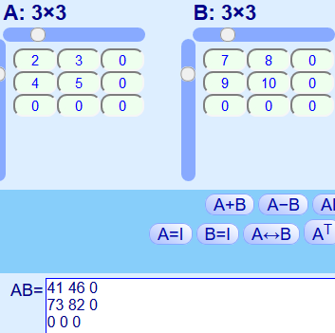  
And this is the result of my program, stored row-wise.  
